### 

### Semester One Examination, 2019

### Question/Answer booklet

# MATHEMATICS METHODS

**UNIT 3**

## Section Two:

## Calculator-assumed

|  |  |
| --- | --- |
| **Your Name:** |  |
| **Your Teacher’s Name:** |  |

## Time allowed for this section

Reading time before commencing work: ten minutes

Working time: one hundred minutes

## Materials required/recommended for this section

***To be provided by the supervisor***

This Question/Answer booklet

Formula sheet (retained from Section One)

***To be provided by the candidate***

Standard items: pens (blue/black preferred), pencils (including coloured), sharpener, correction fluid/tape, eraser, ruler, highlighters

Special items: drawing instruments, templates, notes on two unfolded sheets of A4 paper, and up to three calculators approved for use in this examination

## Important note to candidates

No other items may be taken into the examination room. It is **your** responsibility to ensure that you do not have any unauthorised material. If you have any unauthorised material with you, hand it to the supervisor **before** reading any further.

|  |  |  |  |  |  |
| --- | --- | --- | --- | --- | --- |
| Question | Marks | Max | Question | Mark | Max |
| 8 |  | 6 | 15 |  | 8 |
| 9 |  | 8 | 16 |  | 8 |
| 10 |  | 6 | 17 |  | 10 |
| 11 |  | 4 | 18 |  | 8 |
| 12 |  | 10 | 19 |  | 8 |
| 13 |  | 9 | 20 |  | 11 |
| 14 |  | 8 |  |  |  |

**Structure of this paper**

|  |  |  |  |  |  |
| --- | --- | --- | --- | --- | --- |
| Section | Number of questions available | Number of questions to be answered | Working time (minutes) | Marks available | Percentage of examination |
| Section One:  Calculator-free | 7 | 7 | 50 | 52 | 34 |
| Section Two:  Calculator-assumed | 13 | 13 | 100 | 103 | 66 |
|  |  |  |  | **Total** | 100 |

**Instructions to candidates**

1. The rules for the conduct of the Western Australian Certificate of Education ATAR course examinations are detailed in the *Year 12 Information Handbook 2019*. Sitting this examination implies that you agree to abide by these rules.
2. Write your answers in this Question/Answer booklet.
3. You must be careful to confine your answers to the specific questions asked and to follow any instructions that are specific to a particular question.
4. Additional pages for the use of planning your answer to a question or continuing your answer to a question have been provided at the end of this Question/Answer booklet. If you use the space to continue an answer, indicate in the original answer space where the answer is continued, i.e. give the page number.
5. **Show all your working clearly.**Your working should be in sufficient detail to allow your answers to be checked readily and for marks to be awarded for reasoning. Incorrect answers given without supporting reasoning cannot be allocated any marks. For any question or part question worth more than two marks, valid working or justification is required to receive full marks. If you repeat any question, ensure that you cancel the answer you do not wish to have marked.
6. It is recommended that you **do not use pencil**, except in diagrams.
7. The Formula sheet is **not** to be handed in with your Question/Answer booklet.

**Section One: Calculator-assumed (104 Marks)**

This section has **thirteen** questions. Answer **all** questions. Write your answers in the spaces provided.

Spare pages are included at the end of this booklet. They can be used for planning your responses and/or as additional space if required to continue an answer.

● Planning: If you use the spare pages for planning, indicate this clearly at the top of the page.

● Continuing an answer: If you need to use the space to continue an answer, indicate in the original answer space where the answer is continued, i.e. give the page number. Fill in the number of the question that you are continuing to answer at the top of the page.

Working time: 100 minutes.

**Question 8 (6 marks)**

Consider the following table.

|  |  |  |  |  |  |
| --- | --- | --- | --- | --- | --- |
| $$x$$ | 1 | 2 | 3 | 4 | 5 |
| $$P\left(X≤x\right)$$ | 0.1 | 0.4 | 0.7 | 0.9 |  |

1. Complete the probabilities in the table below (2 marks)

|  |  |  |  |  |  |
| --- | --- | --- | --- | --- | --- |
| $$x$$ | 1 | 2 | 3 | 4 | 5 |
| $$P\left(X=x\right)$$ | 0.1 |  |  |  |  |

1. Determine $P(x≥4)$ (1 mark)
2. Determine $P\left(x>2\right| x<4)$ (simplify) (3 marks)

**Question 9 (8 marks)**

A liquid is spilled onto a floor forming a circle of radius $r$ metres. The surface area, $A$, square metres, of the spilt liquid is given by $A=\int_{0}^{r}{15e^{\frac{x^{3}}{20}}}dx$.

1. Determine $\frac{dA}{dr}$ when $r=5$ metres. (2 marks)
2. What is the meaning of your answer in (a) above? (2 marks)

The radius, $r$, varies with time, $t$ seconds, by the model $r={\left(5t^{2}+1\right)}^{4}$.

1. Determine $\frac{dA}{dt}$ when $t=1$ second as an **exact** value. (no need to simplify)

(4 marks)

**Question 10 (6 marks)**

Two power poles need to be joined using a wire that is also connected to the ground, as shown below. The two poles are 10 and 20 metres high, and are separated by 30 metres.

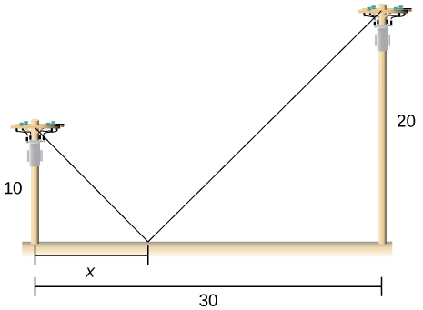

1. Determine an expression for the length of wire needed in terms of $x$ metres. (2 marks)

(No need to simplify)

1. Using **calculus**, show how to determine the value of $x$ to minimize the length of wire required. Determine this length to the nearest centimetre. (4 marks)

(Use of a classpad is required)

**Question 11 (4 marks)**

Part of the graph of $y=f(x)$ is shown below. The areas of regions A and B, bounded by the curve and the $x$-axis, are 16 and 2 square units respectively.



Evaluate:

1. $\int_{2}^{3}{f(x)} dx$ (1 mark)
2. $\int_{0}^{3}{f(x)} dx$ (1 mark)
3. $\int_{0}^{2}{f(x)}-3 dx$ (2 marks)

**Question 12 (10 marks)**

A train on a monorail moves with velocity, $v$ metres per second, at time $t$ seconds, in a straight line, with acceleration, $a$ metres per second squared, given by:

$$a=5\sin\left(3t+\frac{π}{2}\right)$$

The train begins at the origin and at rest.

Determine:

1. The greatest speed of the train. (2 marks)
2. The first time that the train begins to decelerate. (3 marks)
3. An expression for the displacement of the train from the origin. (3 marks)
4. The maximum distance that the train is from the origin. (2 marks)

**Question 13 (9 marks)**

Consider the function $f(x)$ shown graphed below. The table gives the value of the function at the given $x$ values.

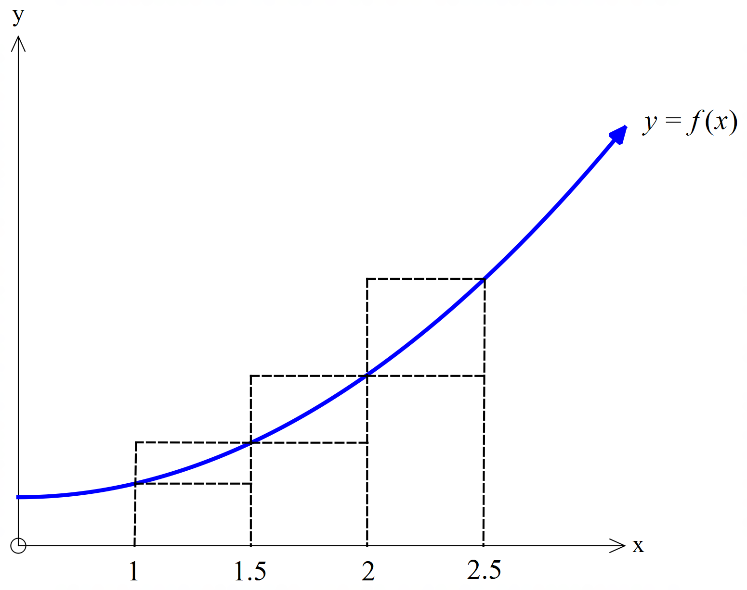

|  |  |  |  |  |
| --- | --- | --- | --- | --- |
| $$x$$ | 1 | 1.5 | 2 | 2.5 |
| $f(x)$ | 1.8 | 2.6 | 3.8 | 5.4 |

1. By considering the areas of the rectangles shown, demonstrate and explain why $4.1<\int_{1}^{2.5}{f\left(x\right)dx}<5.9$  
   . (3 marks)

Consider the table of further values of $f(x)$ given below.

|  |  |  |  |  |  |  |  |
| --- | --- | --- | --- | --- | --- | --- | --- |
| $$x$$ | 0 | 1 | 1.5 | 2 | 2.5 | 3 | 3.5 |
| $f(x)$ | 1 | 1.8 | 2.6 | 3.8 | 5.4 | 7.3 | 9.6 |

1. Use the table values to determine the best estimate possible for $\int_{1}^{3}{2f(x)dx}$ (4 marks)
2. State two ways in which you could determine a more accurate value for $\int_{1}^{3}{2f(x)dx}$

(2 marks)

**Question 14 (8 marks)**

A realtor’s sales history over any month can be represented by the following probability distribution:

|  |  |  |  |  |  |
| --- | --- | --- | --- | --- | --- |
| Number of houses sold in a month | 0 | 1 | 2 | 3 | 4 |
| Probability | 0.15 | 0.4 | 0.3 | 0.1 | 0.05 |

The realtor is paid $1000 every month with a bonus of $1500 for every house sold up to three houses and a special bonus of $1800 if four or more houses are sold in a month.

Let $X=$ the monthly earning of the realtor.

Determine:

1. The expected monthly earning of the realtor, $E(X)$. (4 marks)
2. The standard deviation of $X$. (2 marks)
3. Variance $(5X-3)$. (2 marks)

**Question 15 (8 marks)**

Consider a fair die with the numbers  . The random variable $X$ is defined as the number of times of the thrown die showing an even number on top.

1. If you throw the die 11 times,
2. Determine the probability that you will end up with more even numbers than odd numbers. (2 marks)
3. Determine the probability, to 4 decimal places, that there are in total, even number of times that the die shows an even number. (3 marks)
4. If you would like to throw at least three times an even number. Find the minimum number of times that you need to throw the die for which the probability of three or more even numbers is at least 85%.

(3 marks)

**Question 16 (8 marks)**

The marginal profit from the sale of $x^{th}$ item is given by $P^{'}\left(x\right)=0.0015x^{2}+1.6x-4.8$, where $P\left(x\right)$ is the profit from selling $x$ items.

1. Given that the company incurs a loss of $\$70$ if no items are sold, find an expression for $P$ in terms of $x$. (3 marks)
2. Hence determine the profit from selling 80 items. (2 marks)
3. Find the net change in profit if the number of items sold changes from 80 to 160 items.

(3 marks)

**Question 17 (10 marks)**

The graph of a function $f$ is given below.

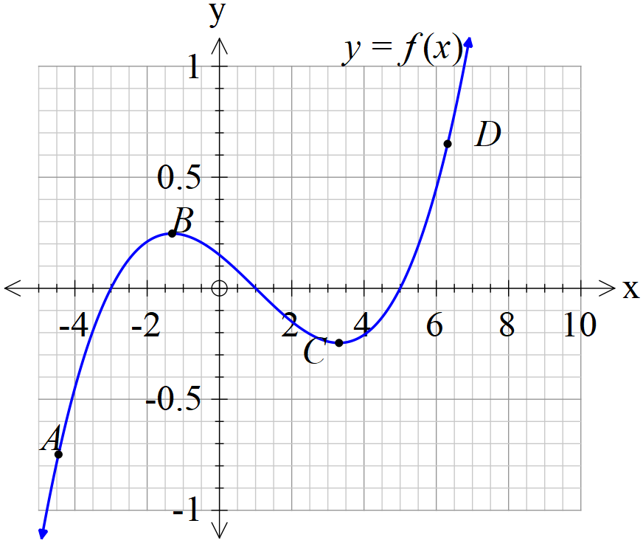

1. $A,B,C,D$ are points on the graph of $f$. Determine whether the first and second derivatives are positive, negative or equal to zero at these points. Record your findings in the table below. (4 marks)

|  |  |  |
| --- | --- | --- |
| Point | $$f'$$ | $$f''$$ |
| A |  |  |
| B |  |  |
| C |  |  |
| D |  |  |

1. Indicate on the graph of $f$ above the inflection point and label as $E$. (1 mark)
2. Sketch the graph of $f'$ on the same axes as the graph of $f$ above. (5 marks)

**Question 18 (8 marks)**

A hovercraft company has established that for selling  units, their revenue function, in dollars, can be given by $R\left(x\right)=3x^{3}+19x^{2}+4x$, and their cost function, in dollars, can be given by $C\left(x\right)=3x^{3}+20x^{2}-96x-80000.$ (Profit=Revenue-cost)

1. Using calculus methods, determine the number of units, ,to maximise the profit.

(4 marks)

1. Determine the selling price per unit to establish the maximum profit in (a) above.

(2 marks)

1. What is the average cost of producing $100$ items? (2 marks)

**Question 19 (8 marks)**

Consider the following 3 equations, where $m$ is a positive real constant:

$$f(x)=x^{2}-3x+4$$

$$g(x)=3x+4$$

$$h(x)=mx+4$$

The graphs of $y=f(x)$ and $y=g(x)$ are shown on the axes below.

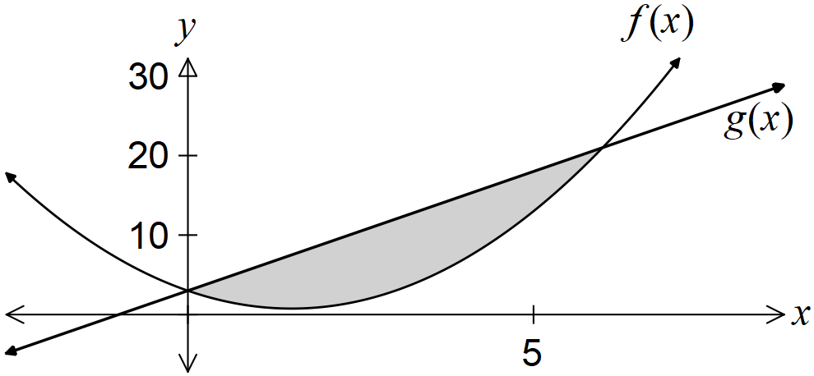

1. State the integral required to calculate the shaded area. (2 marks)
2. Show that the graphs of $y=f(x)$ and $y=h(x)$ intersect when $x=0$ and $x=m+3$.

(2 marks)

1. The area trapped between the graphs of $y=f(x)$ and $y=h(x)$ is 36 square units. Determine the value of $m$. (4 marks)

**Question 20 (11 marks)**

On a tarmac of a wide airfield is a rotating light that has two complete revolutions per second.

( radians/second) The light is placed 200 metres in front of a long brick wall as shown in the diagram below. As the light is shone against the wall, the spot of light can be seen racing across the wall. Let  = the displacement of the spot of light from the point closest to the light, point O, on the wall.

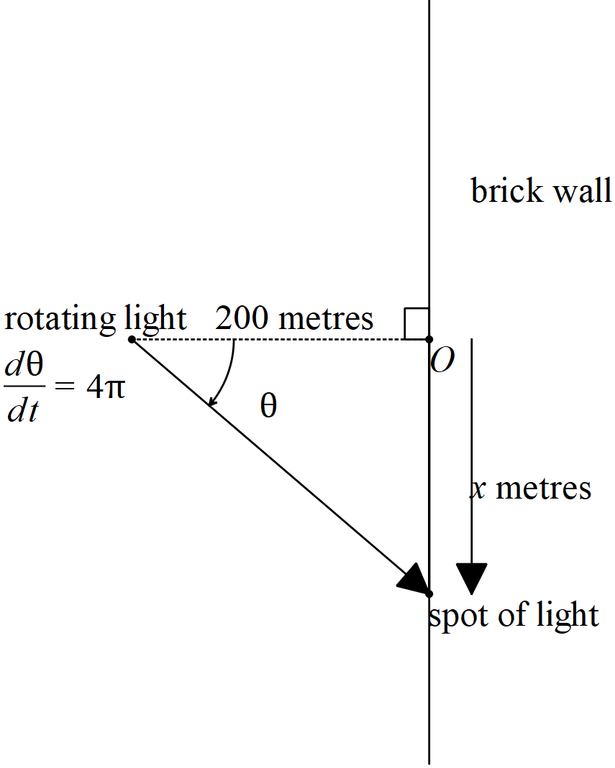

a) Show that . (1 mark)

b) By using  and the quotient rule, show that  (3 marks)

(Hint -trig identity  )

Q20 continued

c) Determine the velocity of the spot of light,  in metres/second, when  radians.

(Hint- use  with ) (3 marks)

d) Determine the acceleration of the spot of light when  radians. (4 marks)

Additional working space

Question number: _______

Additional working space

Question number: ________

Additional working space

Question number: ________